Name: Sapargali Temirlan
Group: SE-2403
Instructor: Kozhakhmet Zhaksylyk
PART 2
TASK 3
Deriverables
All deliverables such as the contract files and e.t.c, are inside same directory as this document.
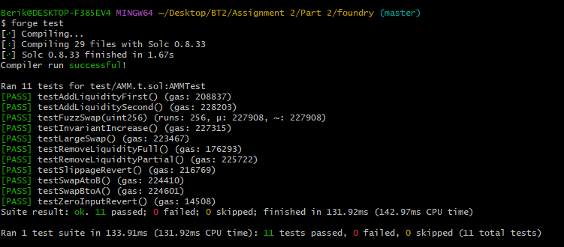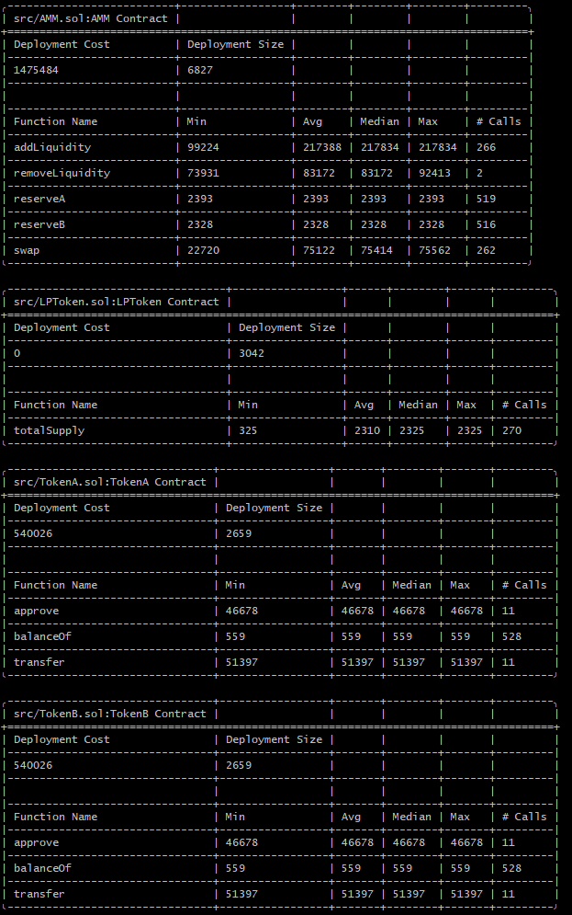
TASK 4
Deliverables

Why the Constant Product Formula Works
The AMM enforces:
$$x⋅y=k$$
$$x⋅y=k$$
Ensures continuous liquidity
Prevents pool depletion
Price is derived implicitly:
$$P=\frac{y}{x}$$Effect of 0.3% Fee
Swap formula:
$$\text{amountInWithFee}=amountIn⋅0.997$$
Fee stays in pool
Therefore:
$$k_{new}>k_{old}$$
This is how LPs earn yield

Impermanent Loss (IL)
Impermanent loss formula:
$$IL=\frac{2\sqrt{r}}{1+r}-1$$
$$IL=\frac{2\sqrt{r}}{1+r}-1$$
Where:
$r=$price ratio change

For 2x price increase:
$$IL≈-5.72\%$$
Meaning:
LP loses ~5.7% vs holding

Price Impact
Price impact grows with trade size:
$$\text{Price Impact}∝\frac{Δx}{x}$$
Large trades:
Move price significantly
Cause slippage

